SQL Queries:

Assignment-1:

1.select film.film_id, title, rating

-> from film

-> join film_category on film.film_id=film_category.film_id

-> join category on film_category.category_id=category.category_id

-> where rating = "PG-13"

-> and category.name="Comedy";

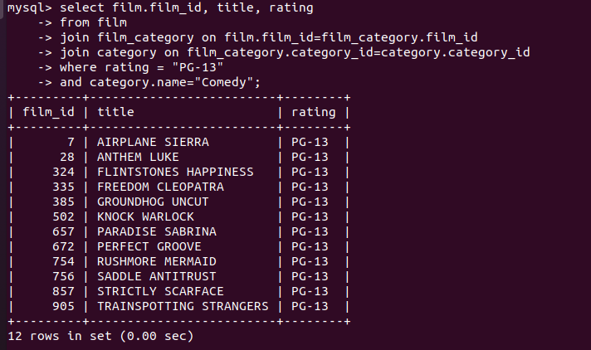

2.select film.title, count(film.title) ,category.name

-> from film

-> join inventory on film.film_id=inventory.film_id

-> join rental on inventory.inventory_id=rental.inventory_id

-> join film_category on film.film_id=film_category.film_id

-> join category on film_category.category_id=category.category_id

-> where category.name = "Horror"

-> group by film.title

-> order by count(film.title) DESC

-> limit 3;



3.select customer.customer_id, customer.first_name, customer.last_name, count(customer.customer_id) as Rent

-> from customer

-> join rental on customer.customer_id = rental.customer_id

-> join inventory on rental.inventory_id = inventory.inventory_id

-> join film_category on inventory.film_id = film_category.film_id

-> join category on film_category.category_id = category.category_id

-> join address on customer.address_id = address.address_id

-> join city on address.city_id = city.city_id

-> join country on city.country_id = country.country_id

-> where category.name = "Sports"

-> and country.country = "India"

-> group by customer.customer_id;

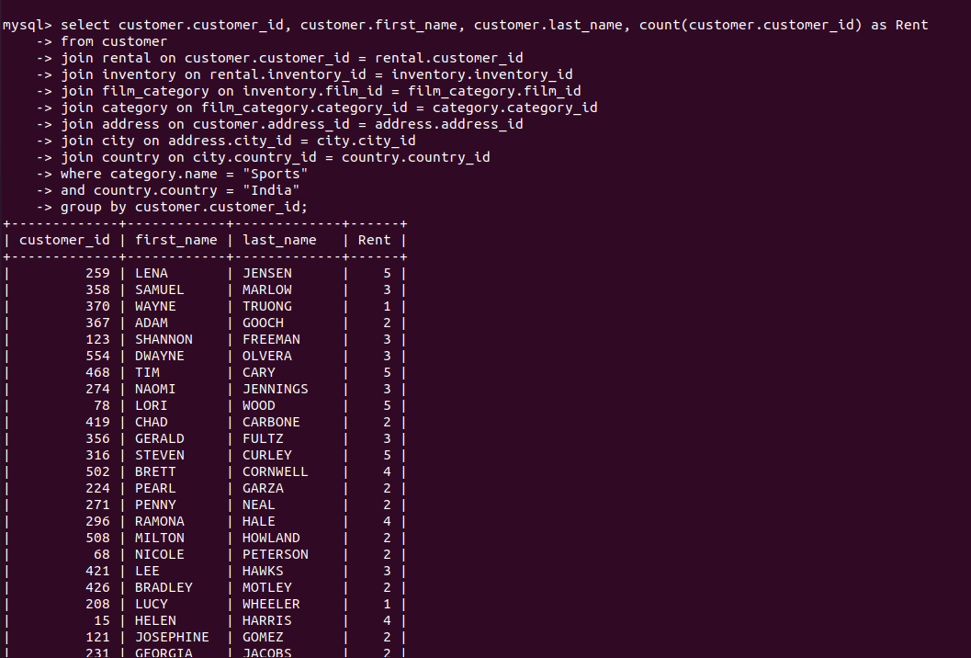

4.select customer.first_name, customer.last_name ,actor.first_name,actor.lastname

-> from customer

-> join rental on customer.customer_id = rental.customer_id

-> join inventory on rental.inventory_id = inventory.inventory_id

-> join film_actor on inventory.film_id = film_actor.film_id

-> join actor on film_actor.actor_id = actor.actor_id

-> join address on customer.address_id = address.address_id

-> join city on address.city_id = city.city_id

-> join country on city.country_id = country.country_id

-> where country.country = "Canada"

-> and actor.first_name = "NICK"

-> and actor.last_name = "WAHLBERG"

-> group by customer.customer_id;

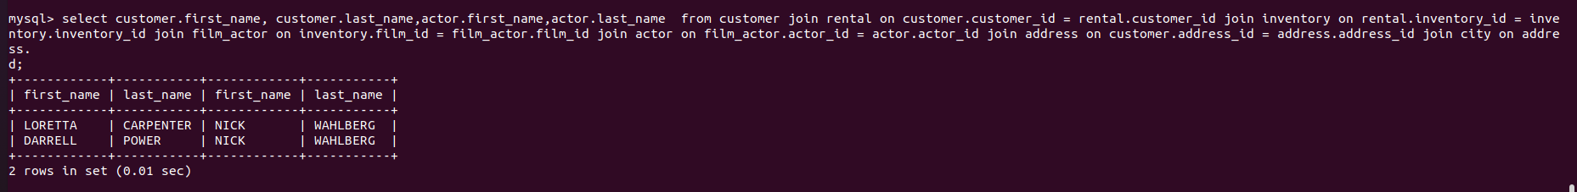

5.SELECT count(film_id) as Total_Films FROM film_actor WHERE actor_id IN (SELECT actor_id FROM actor WHERE actor.first_name = "SEAN" AND actor.last_name= "WILLIAMS");

